- Incremental model and Prototyping model are two commonly used process models in software projects.

  - Discuss a scenario that is suitable or useful to adopt the prototyping model.
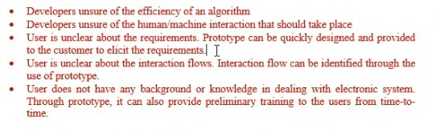

  - Explain the process involved in incremental software process model.
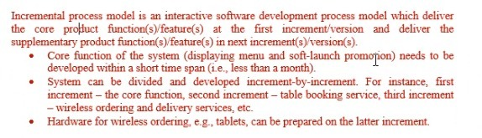

  - Why the incremental process model is considered by many IT professionals to be the best approach to software development in the current software industry?
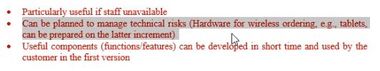

- You as an IT manager of Cozzway Direct Selling Sdn. Bhd. are required to develop an online system which will provide services for its distributors and customers. Among other services, the system should allow users to view product and promotion details, register as a distributor, make orders and payments, track order status, check on distributor’s points accumulated and perform redemption based on points entitlement.

The distributors and customers of this company basically come from all parts of Malaysia with different education background, level of computer knowledge as well as preference of language. Currently, the IT department consists of three staff under your supervision, i.e. one systems analyst and two programmers. This could be a challenging project as it concerns a new area that your team has not ventured into before. The requirements gathered were clear and could be modularized easily. The top management requires that the new online system be completed within three months.

Recommend, with explanation, an appropriate software process model to complete the project. Justify your recommendation. You may state any relevant assumptions to support your answer.

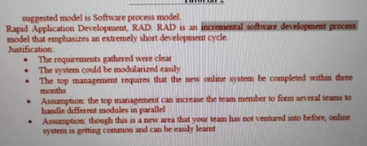

- Highlight the distinct feature(s) and suggest a scenario where Spiral model is suitable to be adopted.

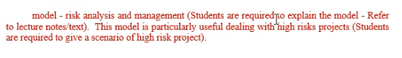

- JC grocery is a mid-sized family business that operates since 30 years ago. The main operations in the grocery store, i.e., stock in and stock out, are still performed manually. To ease the daily operations, the owner of JC grocery wants to computerize the stock in and stock out operations in the stores. In addition, he also wants to enable online-ordering services to the clients. Nevertheless, the owner does not have any background or knowledge in computerized and online systems.

If you are the project manager of a software solution company, analyze the description above and suggest the most suitable process model to be used in case study above. Justify your suggestion. You may state any assumptions in supporting your justifications.
suggested model is Prototyping model.
Software customers and end-users usually find it very difficult to express their real requirements. A system prototype can be developed to give end-users a concrete impression of the system capabilities.
Justification:
- User is unclear about the requirements. Prototype can be quickly designed and provided to the customer to elicit the requirements.
- User is unclear about the interaction flows. Interaction flow can be identified through the use of prototype.
- User does not have any background or knowledge in dealing with electronic system. Through prototype, it can also provide preliminary training to the users from time-to-time.

- Discuss 3 main differences between Plan-Driven Development and Agile Software Development.
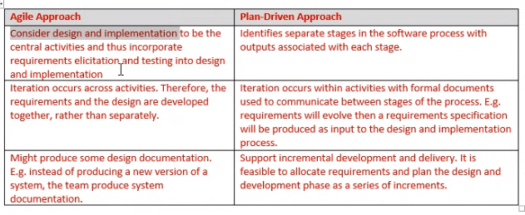

- Delicious restaurant is a new restaurant in town. The restaurant is having a soft-launch in less than a month time. To further increase the popularity of the restaurant, Delicious restaurant has decided to have a website which introduces the menu and soft-launch promotion to the customers. After that, Delicious restaurant also wants to have an online system to enable table-booking services to the customers. In the future, Delicious restaurant also wishes to extend their online system to provide wireless ordering and delivering services.

If you are the project manager of a software solution company, analyze the description above and suggest the most suitable process model to be used in the above case study. Justify your answer. You may state any assumptions in supporting your justifications.
suggested model is Incremental model.
Incremental process model is an interactive software development process model which deliver the core product function(s)/feature(s) at the first increment/version and deliver the supplementary product function(s)/feature(s) in next increment(s)/version(s).
Justification:
- Core function of the system (displaying menu and soft-launch promotion) needs to be developed within a short time span (i.e., less than a month)
- System can be divided and developed increment-by-increment. For instance, first increment – the core function, second increment – table booking service, third increment – wireless ordering and delivery services, etc.
- Hardware for wireless ordering, e.g. tablets, can be prepared on the latter increment.

- With the aid of examples, discuss any 5 principles of Agile Software Development.

Any 5 principles of Agile development principles with examples:
- Customer satisfaction by rapid delivery of useful software
- Welcome changing requirements, even late in development
- Working software is delivered frequently (weeks rather than months)
- Working software is the principal measure of progress
- Sustainable development, able to maintain a constant pace
- Close, daily co-operation between business people and developers
- Face-to-face conversation is the best form of communication (co-location)
- Projects are built around motivated individuals, who should be trusted
- Continuous attention to technical excellence and good design
- Simplicity- The art of maximizing the amount of work not done - is essential
- Self-organizing teams
- Regular adaptation to changing circumstances

